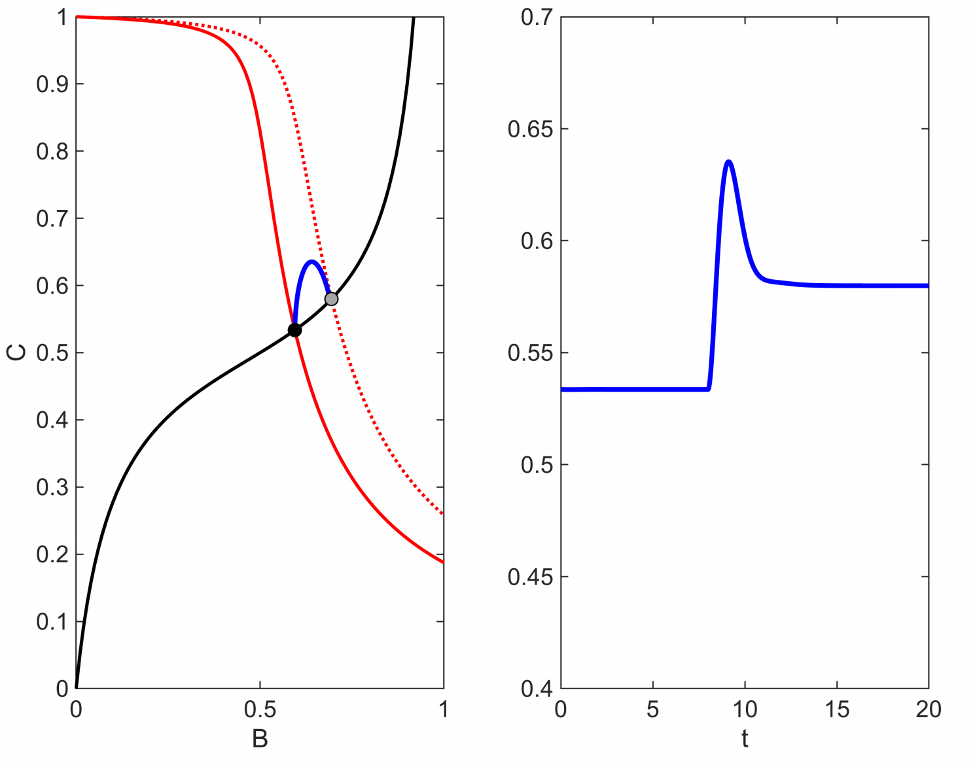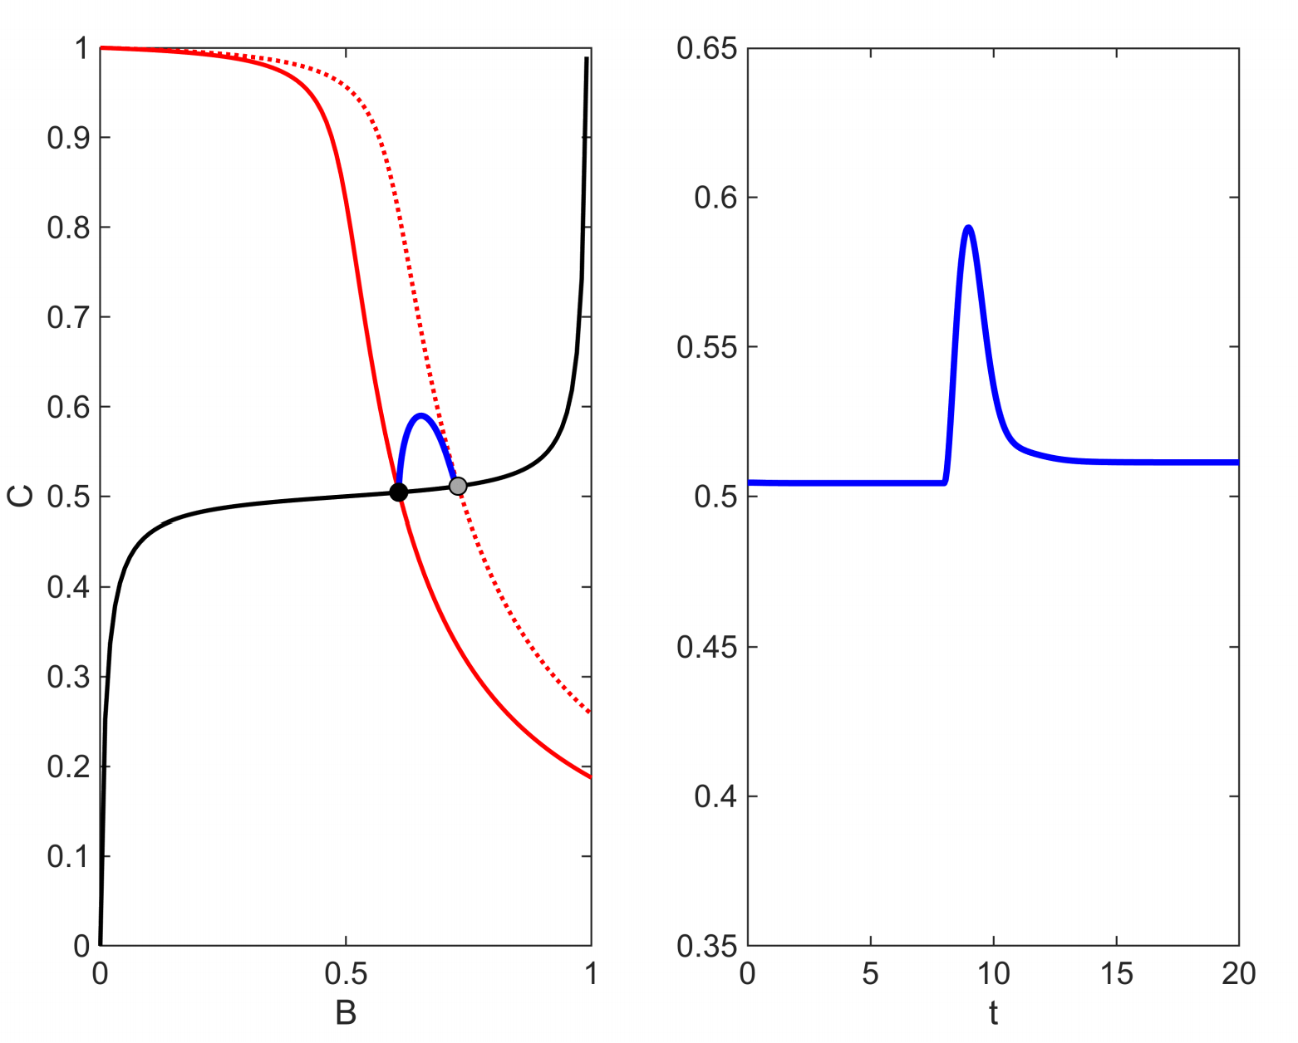

Sensitivity = 0.8450≈1

Precision = 14.8943>10

NFBLB

Sensitivity = 0.9529≈1

Precision = 2.3054<10

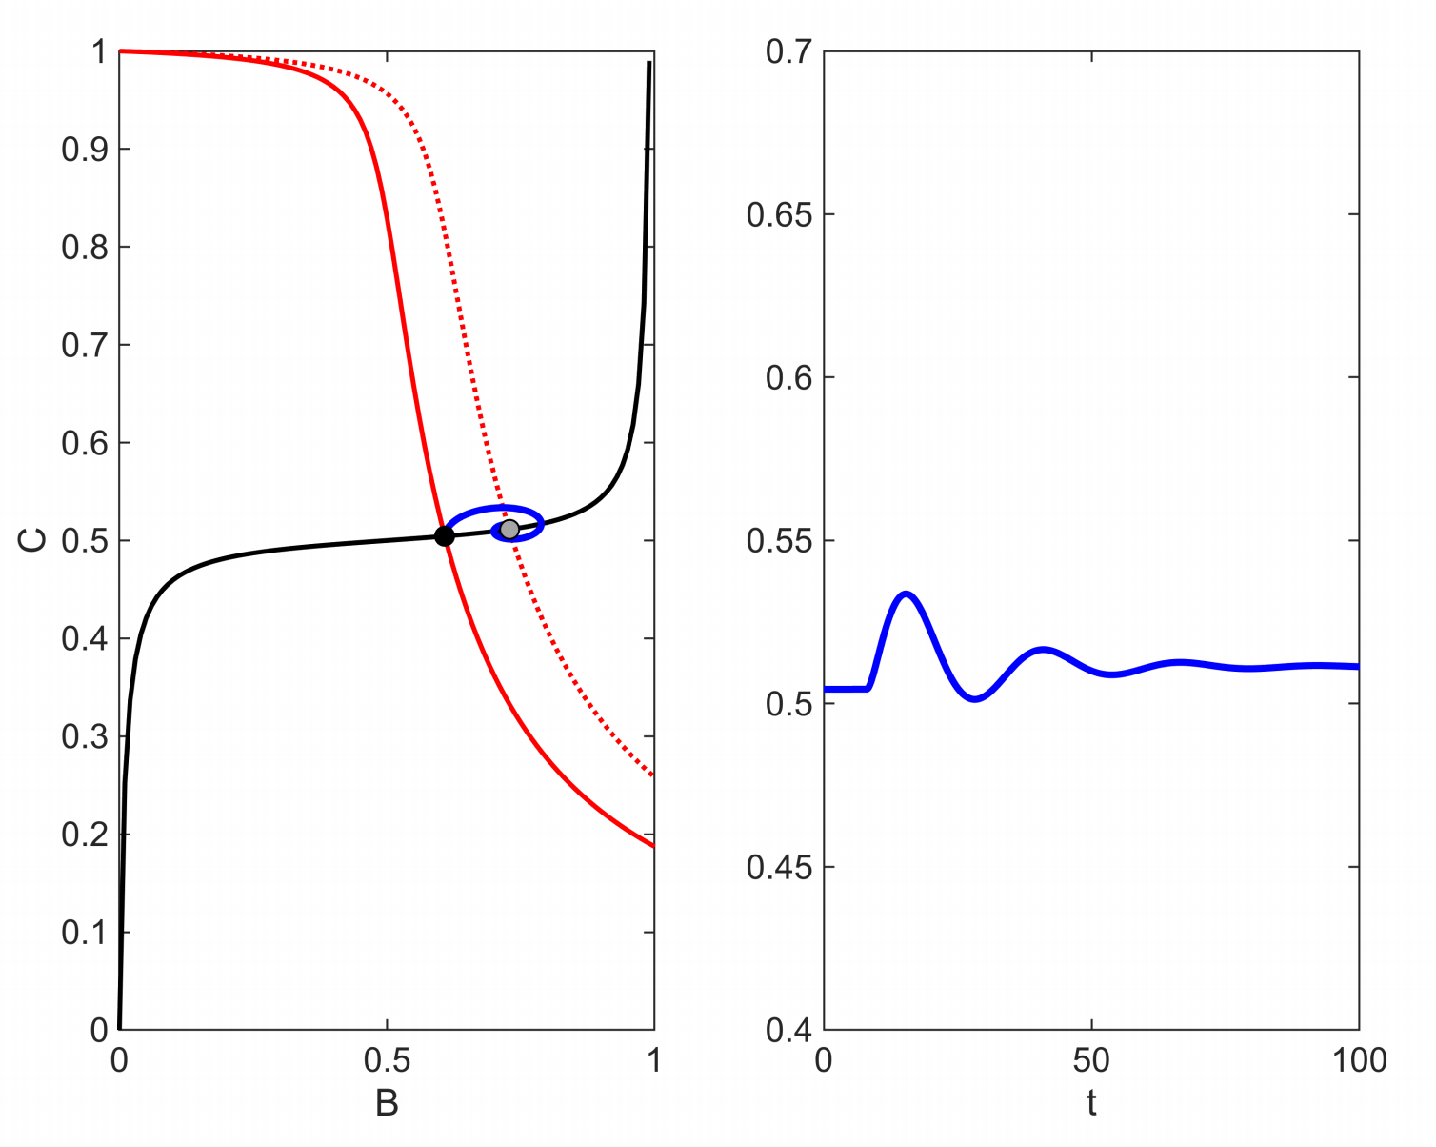

Sensitivity = 0.2894<1

Precision = 14.6111>10

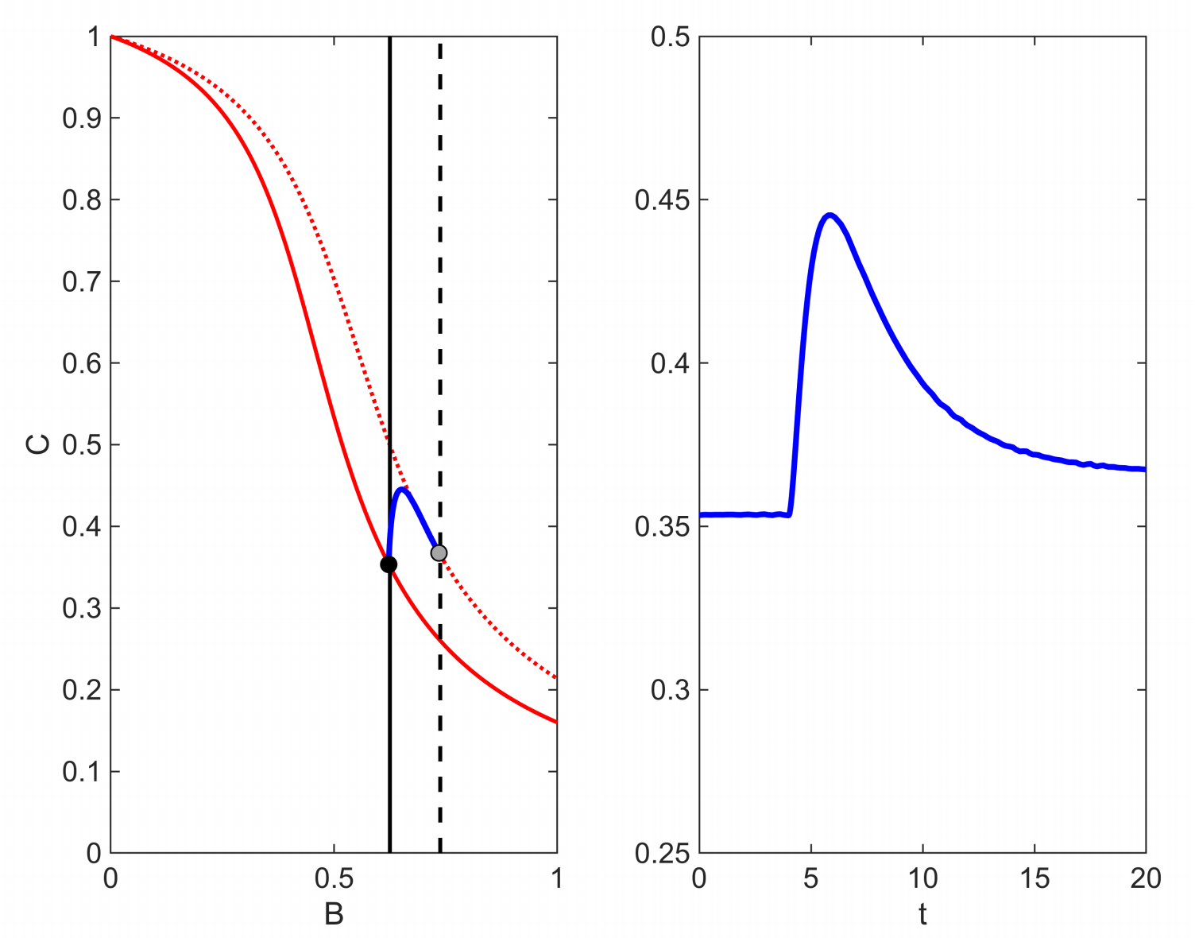

IFFLP

Sensitivity = 1.2992>1

Precision = 5.0460<10

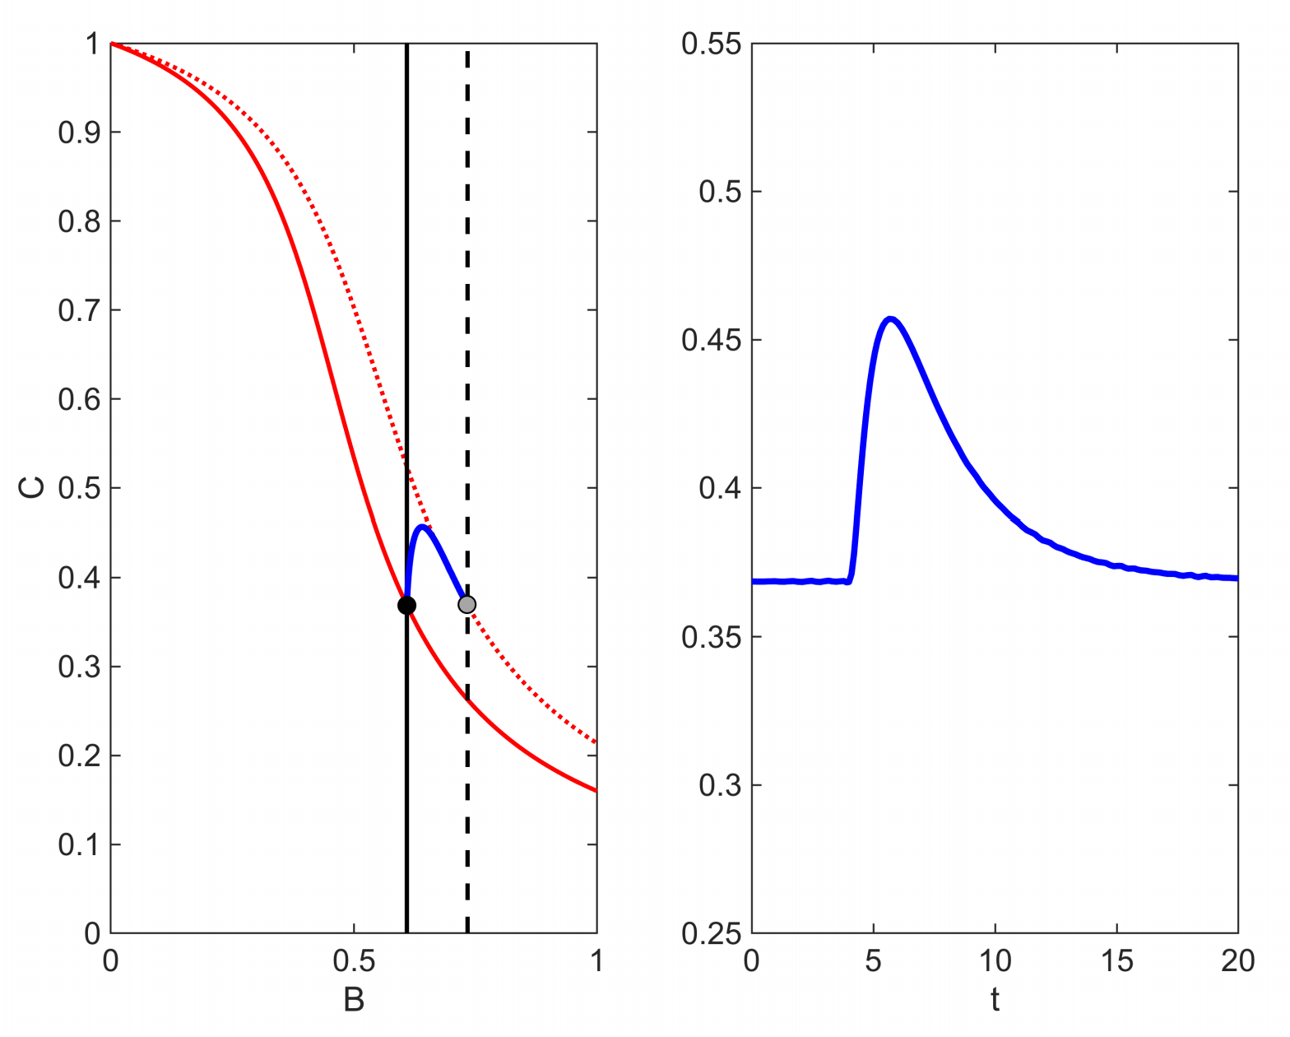

Sensitivity = 1.1975>1

Precision = 71.0747>10

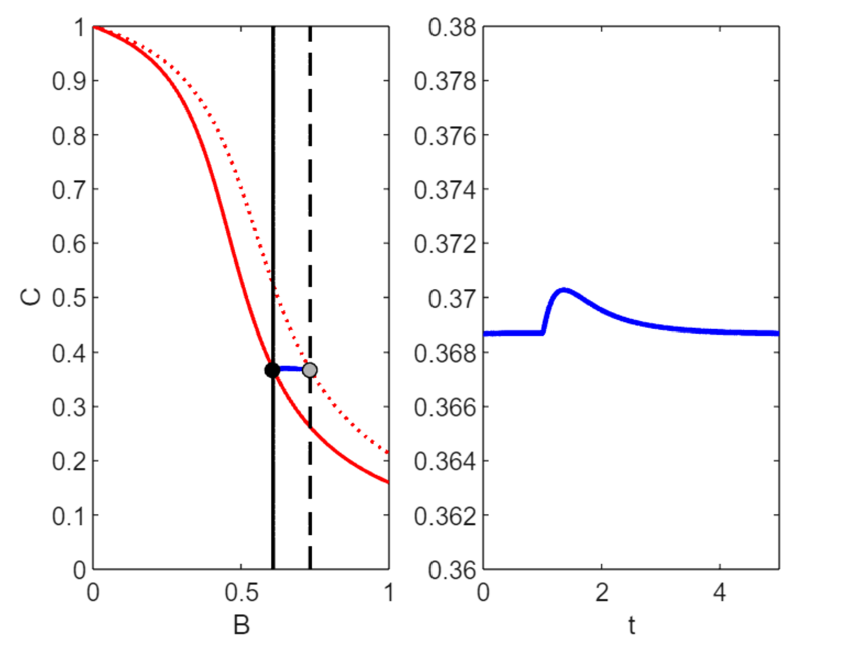

Sensitivity = 0.0214<1

Precision = 6809.4>10